VistA Scheduling Enhancements (VSE)

VS GUI
Installation Guide Version 1.01

NOTE: Only approved for installation to VistA Test Environments



May 2016

Department of Veterans Affairs

Office of Information and Technology (OI&T)

Revision History

Date | Version | Description | Author
5/4/16 | 1.01 | Removed Manual Install Instruction. Link to SCCM package was added. All vista patches associated with this  release have been documented in the  guide, along with the installation order. | D. Reed
5/1/16 | 1.0 | Initial Baseline | D. Reed

Table of Contents
- Getting Started 1
  - Security Keys 1
  - General Information 2
  - VistA Server Requirements 2
  - Client PC Requirements 2
  - Installation Issues 2
  - Software Download 2
- Logging on to the VS GUI 3
Table of Figures
Figure 21: VistA Scheduling Log In Screen 3
- Getting Started

This section provides an overview of the security keys, VistA server requirements, the client PC requirements and the process for acquiring the GUI software.

The VS GUI should ONLY be installed in TEST environments until approval from the VHA Release Board is obtained to load into facility production environments

  - Security Keys

The VistA Scheduling (VS) Graphical User Interface (GUI) uses security keys to limit the user’s ability to change system set-up parameters and patient information. Note that not all VS GUI options are available to all users. Contact the site administrator to determine or change security keys.

All VistA users are required to observe the Department of Veterans Affairs (VA) Rules of Behavior regarding patient privacy and the security of both patient information and VA computers and networks.

Perform the following steps in VistA to configure the VS GUI security profile:

- Within the VistA environment, assign the SDECZMENU security key. All Scheduling users must have the SDECZMENU security key.
- Users who are Scheduling Managers must have the SDECZMGR key assigned. The SDECZMGR key permits access to the Systems tab in the VS GUI application. This menu supports the creation of clinic groups and assignment of Privileged Users to Prohibited clinics. See the VS GUI User Manual for detailed instructions.
3. Users who are Scheduling and have the responsibility of managing the Veterean Appointment Request (VAR) mobile request will need SDECZ REQUEST key assigned. The SDECZ REQUEST key permits access to the Mobile Request icon on the ribbon bar of the task tab. See the VS GUI User Manual for detailed instructions. Note: Do not assign in the VistA TEST environment.
- When setting up users in VistA Menu XUSEREDIT, users must have a Default Division (Page 1) defined, Multiple Sign-on must be set to Allowed (Page 2), Restrict Patient Selection must be set to NO (Page 4) , and CPRS GUI core tabs (Page 4) must be defined in the CPRS Access Tab.
- Make the SDECRPC menu options available to Scheduling users. These options must be somewhere in the user’s path, either as a secondary option or as members of a menu to which the user has access.
- Log in to VistA with the VS GUI
- Use the VS GUI, Systems tab, Scheduling Management button, to configure the following:
  - Assign new privileged users to a prohibited clinic Clinic groups
  - General Information

It is recommended that the terminal output during the installation be captured using an auxport printer attached to the terminal at which software installation is being performed. This provides a printed audit trail if any problems should arise.

  - VistA Server Requirements
    - Cache version 5.0
    - Kernel version 8
    - Patient Information Management System (PIMS) version 5.3 patch 1012

  - Client PC Requirements
    - Microsoft Windows XP or Windows 7
    - Microsoft .NET Framework 4.0
    - Microsoft Data Access Components (MDAC) current version

  - Installation Issues
There are no installation issues to report. However, patches must be installed in this order: GMRC*3.0*83
SD*5.3*627
SD*5.3*628 SD*5.3*643 SD*5.3*642 SD*5.3*645

The patches above are to be installed in the order listed
except for SD*5.3*645 which is a standalone patch and can be installed at any time.

  - Software Download
The software will automatically installed to the users PC via a push from the SCCM Administrator team.
SCCM Build Document:
http://vaww.eie.va.gov/SysDesign/CS/Shared%20Documents/Build%20Docume nts/Application%20Tier%203%20and%204/ESE%20VA%20VistA%20Scheduling
%20GUI_T%20Build%20Document.pdf
- Logging on to the VS GUI

Use the following steps to log on to the VS GUI, using the VistA Scheduling shortcut.

- On the desktop, double-click the VistA Scheduling - Shortcut icon. The VS GUI application opens and the log in screen displays.

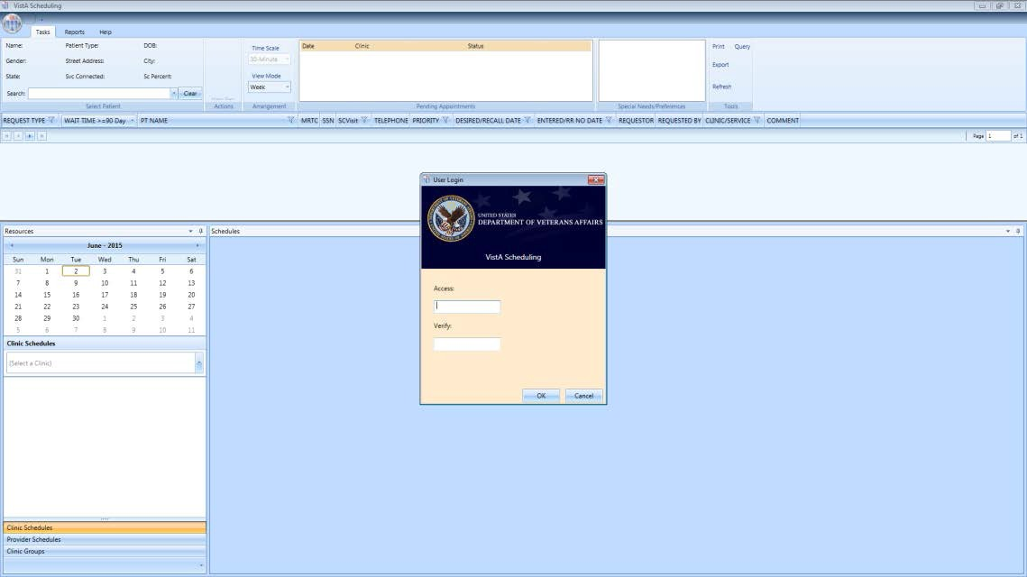
Figure 1: VistA Scheduling Log In Screen

- Enter valid Access and Verify codes.
- Click OK to complete logging in to the VS GUI.

